- Summary As the nation’s largest Fast Charging Network, TecGo has ambitious plans to increase its national footprint by 2,000 chargers over the next several years.

Part I - Planning
  - Prepare a 2-year Capex Plan to be used as an input to the broader Financial Model. There should be an output tab with monthly Capital Expenditures.
  - Presentation or memo answering the following questions (approximately 5-10 pages but no technical limit):
    - Describe and list key milestones and standard cost elements of a charging station construction project. Assume equipment is provided by TecGo and Construction services by multiple providers across various localities.
    - In addition to the timing of a construction project itself, what are some other considerations that need to be made in planning for network expansion and how do you integrate those into your capital expenditure projections?
    - What unforeseen or specific situations might impact the standard milestone and cost elements from (a)? How would you account for such unforeseen impacts in your projections?
    - Think about which groups across the organization will have a need for the information contained in your plan and explain why. Also, provide specific views of data that you would prepare for them to fulfill their needs. (2-3 examples will suffice but no technical limit)

Part II – Project Cost Tracking
  - It is March 2021 and one of the charging stations in your plan became operational on 2/15/21. Prepare a project cost report to be used as a reference for the amount to be capitalized and depreciated on the balance sheet.
- Using the images in the attached Station Types 1-3 and publicly available information as a guide for your assumptions, create a sample Project Cost report including all Project invoices
- Invoice detail should include Vendor Category, Invoice Date, Cost, and any other information you deem to be
relevant. Vendor names can be actual or hypothetical
- For each invoice, identify how you would have coded it in the accounting general ledger when it was paid. For the purposes of this exercise, assume invoices are paid upon receipt.

- A few notes:
  - A single charging station may have multiple chargers and types of chargers (per examples Types 1-3)
  - Charging Stations take anywhere from 2-5 months to construct
  - Charging Stations are most frequently located at public retail locations such as grocery stores and shopping centers, with some located on public property (libraries, civic centers)
Station Type 1 Station Type 2
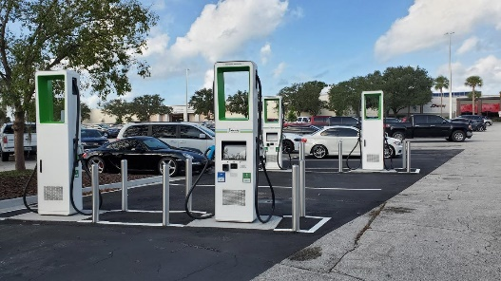
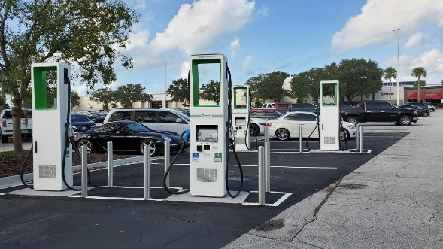
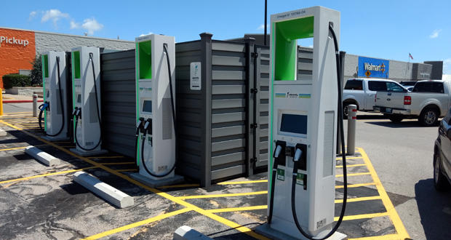

Station Type 3

